1. Print odd number using array (arrow fun, anonymous fun, IIFE fun)

* **Arrow function**

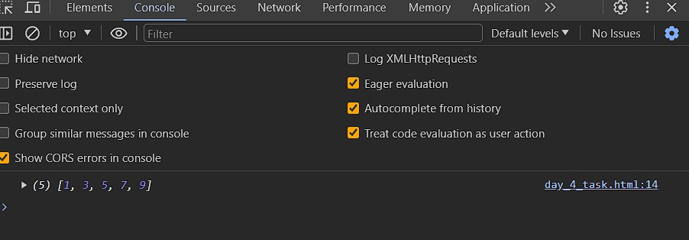

* **Anonymous function**

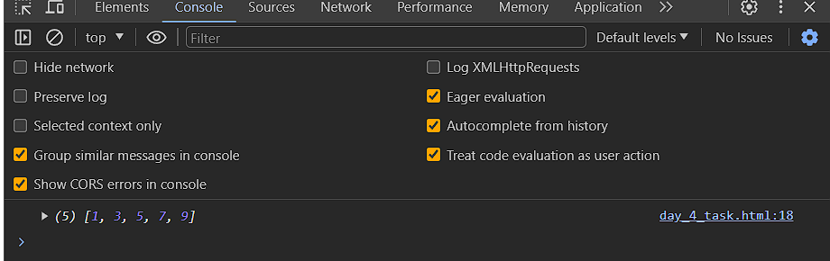

* IIFE function

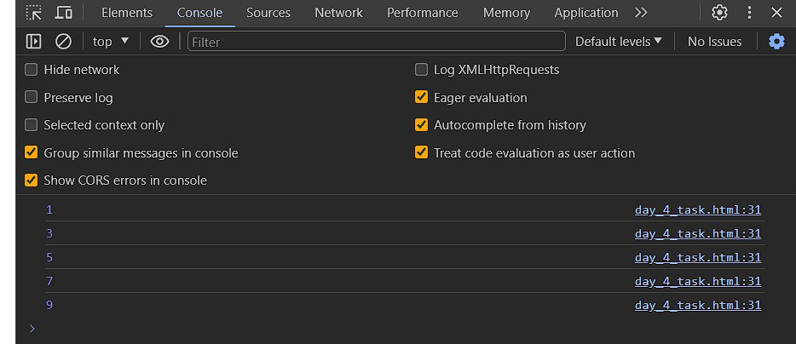

b convert all the string to title caps in a sting array

* IIFE Function

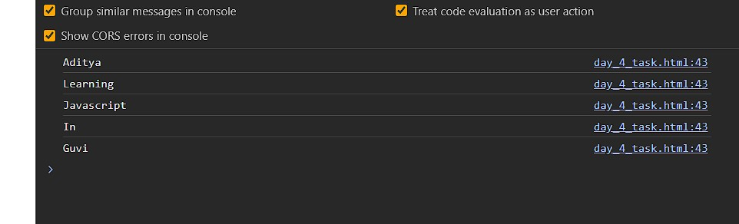

* anonymous function



* arrow function



C . Return all the prime numbers in an array

* IIFE FUNCTION

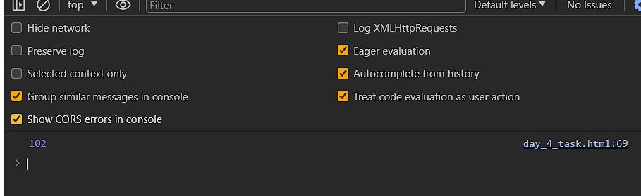

* anonymous function



* arrow function



d. Return all the prime numbers in an array

* IIFE FUNCTION

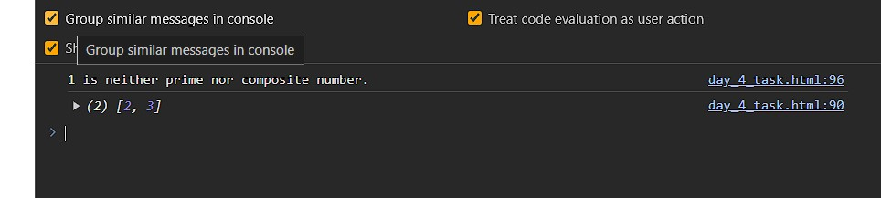

* anonymous function



* arrow function



E . Return all the palindromes in an array

* IIFE FUNCTION

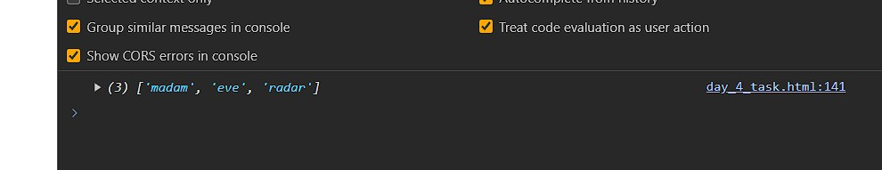

* anonymous function

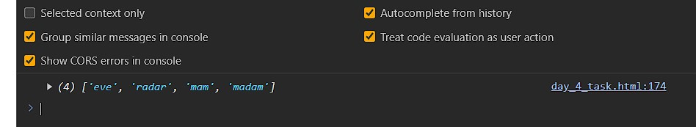

* arrow function



F . Return median of two sorted arrays of same size

* IIFE FUNCTION

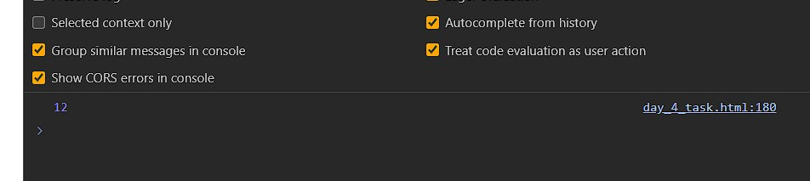

G. Remove duplicates from an array

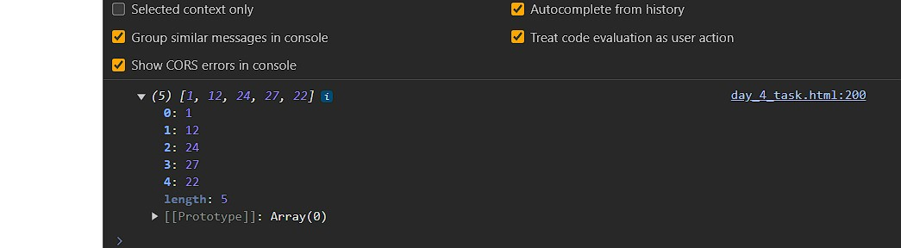

H. Rotate an array by k times

